THE LOST WORLD READ 2009 ACTIVITY SHEETS

Colouring and Drawing Sheets

© Aardman Animations Ltd 2008. www.aardman.com
Colour in this picture of Wallace and Gromit. Who – or what – do you think is watching them?
Here are some pictures of prehistoric creatures for you to colour in. Add to each picture a drawing of the landscape in which they are living. You could also add some of the characters from The Lost World.

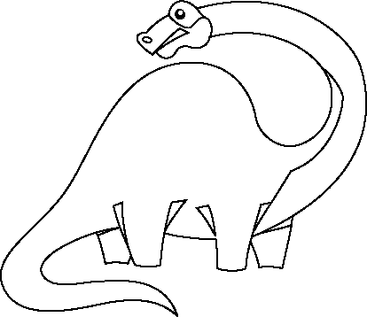

This picture was copied from http://www.prl.ab.ca/ab2001/games.htm

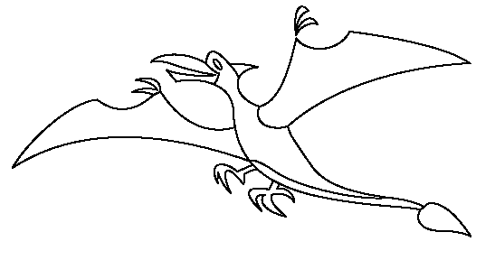

This picture was copied from http://www.prl.ab.ca/ab2001/games.htm

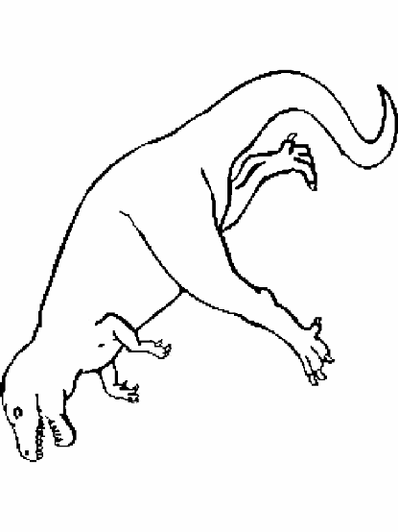

This picture was copied from www.mantyweb.com/dinosaur/trexcoloringpage.htm
Dinosaurs on the Loose

Imagine that there really are still dinosaurs in the world.

In science fiction, writers and artists often mix together something that is familiar with something extraordinary. This makes it even more shocking when strange things happen.

Draw a picture of somewhere you know – it might be your playground or the street where you go shopping or a famous landmark in your home town.

Now add a dinosaur to your drawing. It might be a peaceful, lumbering dinosaur, like the family of iguanodons in The Lost World. Or it might be a frightening one, like the carnivore that attacked them.

Pretend you are a reporter like Malone. Write a short newspaper report to go with your picture about what happened when the dinosaur was on the loose.

Go to the Natural History Museum’s Dino Directory at http://www.nhm.ac.uk/jdsml/nature-online/dino-directory/ to see pictures of different types of dinosaurs to help you with your drawing.
Design a Book Cover

Here are some different covers that have been used on The Lost World.

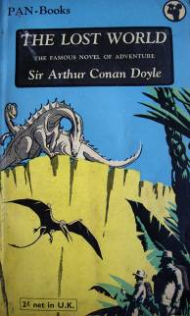 | 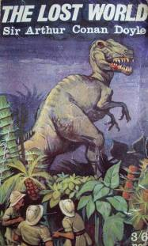
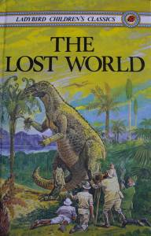 | 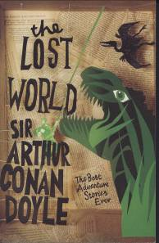

Design your own cover for a new edition of the book.

The Lost Book

A priceless book has been stolen and… and what!?

The Lost Book is an online animated whodunit with graphics from Binary Fable, music from the Scottish Chamber Orchestra and story from you, me and everyone who logs on and gets involved!

After the first online episode (which is jam-packed with possible clues) where the story goes is a collaborative adventure!

So first find the website www.thelostbook.net then together we’ll find the lost book in this intriguing, 21st century spin on The Lost World.

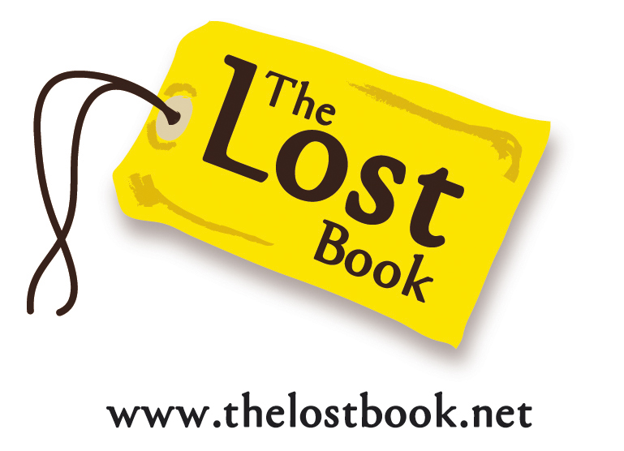

Dinosaurs and extinction

No dinosaur fossils have been found in rock less than 65 million years old. That means that the dinosaurs must have all died out and become extinct 65 million years ago. Why might this have happened?

Some scientists think the dinosaurs grew so heavy their skeletons could no longer support their weight and they collapsed. Or perhaps they died from a new disease or were poisoned by a new kind of plant. Other creatures might have eaten all their food and stolen their eggs. Or maybe the environment on Earth changed and it was no longer suitable for dinosaurs.

‘The environment’ means all the things that surround us like the air, the surface of the land, the temperature, the food available. If the environment had changed slowly, then the dinosaurs might have had a chance to change too. We call these gradual changes ‘evolution’: things evolve step by step, over time. However, if the change in the environment happened suddenly then the dinosaurs would not have had time to evolve.

A huge lump of rock called a meteorite might have come from outer space and hit the Earth. Everything that lived close to where the meteorite landed would have been killed. The dust and gases that filled the air would have blocked out the sunlight. It would have become cold and dark, and many plants would have died. If there were no plants, then the dinosaurs that lived on plants would have died too. Then the meat-eating dinosaurs would have died, as they would not have had enough to eat either. When the dust settled, there would have been a mist hanging in the air. This would have trapped the heat from the sun, like a greenhouse, so it became too hot for the few dinosaurs that remained. This may explain what happened to the dinosaurs, but we still do not know how some other creatures could survive this terrible disaster or were able to evolve.

There is a lot of information about dinosaurs on the internet, including games you can play and other activities. Here are a few of the websites you can visit:

Dinosaurs for Kids http://www.kidsdinos.com/

Surfing the Net with Kids: Dinosaur Games http://www.surfnetkids.com/games/Animal_Games/Dinosaur_Games/

Dinosphere http://www.childrensmuseum.org/games/grades_3-5.htm

Dinomite Days http://www.dinomitedays.org/fun.htm

Dino Jaws http://www.nhm.ac.uk/visit-us/whats-on/temporary-exhibitions/dino-jaws/activities-index.html

Time Warp http://funschool.kaboose.com/time-warp/dinosaurs/

There’s also an online game based on the television version of The Lost World at http://www.bbc.co.uk/drama/lostworld/games/lostworld_feature_ssi.shtml

Looking after the environment

Many other plants, birds, insects and animals have become extinct since the dinosaurs. Many have died out not because of natural disasters (like a meteorite) but because of things that humans do.
Hunting to extinction: The great auk was a bird that could not fly. It lived on islands in the North Atlantic Ocean. At first it was isolated from humans so was safe, but it was eventually hunted to extinction in the nineteenth century. If too many creatures are killed then a species will become extinct as there aren’t enough left to breed and survive. Extinction is forever.

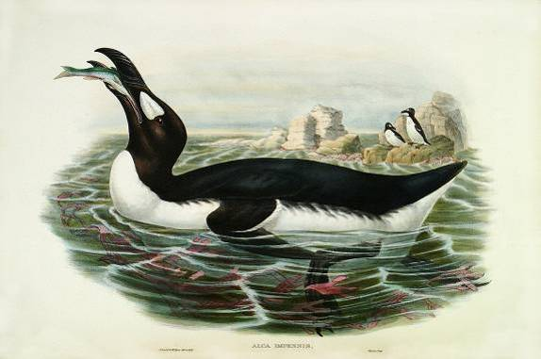

Cutting down too many trees: People need wood to make things or to clear land for building or farming, but animals and birds also need the trees for food and as safe places to live. In Madagascar, there used to be lots of lemurs living in the forests but because so many trees have been cut down there are now very few of these lovely animals left in the wild.
Farming: When people clear the forests and hedges to make fields to grow food, some animals and birds lose their homes. Weed killers that are sprayed on crops can kill wild flowers, insects and birds. Some wild birds and animals are shot, trapped or poisoned because they are thought to be a threat. In Scotland, white-tailed eagles are close to extinction because so many have been killed by farmers and landowners who blame them for stealing sheep and other animals.
Pollution: Pollution, like oil spilled into the sea, piles of rubbish or poisonous chemicals, spoils the environment and harms everything that lives there. In 2006 the Yangtze River dolphin in China as declared extinct. One of the reasons was that the river they lived in had become so dirty.
All living things – including people – are connected together, so if one type of creature becomes extinct then everything else will suffer. It is too late to save the dinosaurs, but by looking after the environment and having places where wildlife is safe, we can stop other living things from disappearing.
You can help by always putting rubbish in a rubbish bin, never damaging or picking wild flowers, reusing carrier bags, recycling glass and paper, using low-energy light bulbs, not wasting water or food, composting, turning things off properly rather than leaving them on standby. If you have a garden, you should avoid putting out slug pellets and using chemicals on the plants, and it is better to walk and cycle, if you can, than to travel by car.
People in the UK working to protect wildlife and the environment include:

ARKive http://www.arkive.org/
Friends of the Earth: http://www.foe.co.uk
Froglife: http://www.froglife.org/
Greenpeace: http://www.greenpeace.org.uk/
Wildlife Trusts: http://www.wildlifetrusts.org/
The Woodland Trust: http://www.woodland-trust.org.uk/

Go to http://www.earthpeace.com/Games.htm for games and activities that help you learn to help the planet.
Feeding stations

One way you can help wildlife is by putting out food for the birds.

Some birds like to eat seeds, like sunflowers. You can buy seeds from most pet shops. Put them somewhere birds will be safe to stop and eat – like up on a bird table or in a bird feeder. If you stay very quiet and still, and do not go too close, you can watch the birds have a treat.

Make a list of all the different types of birds you see. There’s a bird identifier on the Royal Society for the Protection of Birds website at http://www.rspb.org.uk/wildlife/birdidentifier/ or you could borrow a bird book from your library.

You could also make the birds a special fat-feeder (you might need some help with this from a grown up).

Cut a hole in the front of a one-litre milk container (make sure the milk has been drunk first!). The hole should be big enough for a small bird to get in.

Gently melt 250g of hard fat in a pan and mix in three mugs-full of birdseed. You can also use unsalted peanuts but make sure they are broken up into small pieces so the birds don’t choke.

Spoon the mixture into the container and leave it to harden.

Tie some string to the handle of the container and hang it upside down from a tree or hook to keep out the rain and the bigger birds.

At http://www.bbc.co.uk/nature/animals/birds/thingstodo/birdfeeder.shtml you can see a picture of the feeder.

In the spring you could plant sunflower seeds. Sunflowers have a single, tall stalk at the top of which is a large flower head. This head is full of seeds so by growing a sunflower you will be making more food for the birds to eat. See who can grow the tallest sunflower in your class.

